1) Problem Statement : Create a multi-page HTML website with navigation links and a basic registration form using appropriate form elements and validation attributes.
- HTML CODE :
Clg_admission.html:
<!DOCTYPE html>
<html lang="en">
<head>
<title>College Admission - Home</title>
</head>
<body>

<nav>
<a href="index.html">Home</a> |
<a href="contact.html">detials</a>
</nav>

<h1>Welcome to JNTU Engg College</h1>
<p>Apply for admission using our online registration form.</p>

<h2>Admission Open 2026</h2>
<p>Click on the contact page to fill the registration form.</p>

</body>
</html>

Contact.html :
<!DOCTYPE html>
<html lang="en">

<head>
<title>College Admission - Contact</title>
</head>

<body>

<!-- Navigation Bar -->
<nav>
<a href="index.html">Home</a> |
<a href="contact.html">Contact</a>
</nav>

<h1>College Admission Form</h1>

<form>

<label>Full Name:</label><br>
<input type="text" placeholder="Enter your name" required><br><br>

<label>Email:</label><br>
<input type="email" placeholder="Enter your email" required><br><br>

<label>Password:</label><br>
<input type="password" placeholder="Enter password" required><br><br>

<label>Gender:</label><br>
<input type="radio" name="gender"> Female
<input type="radio" name="gender" required> Male
<input type="radio" name="gender">Any Other
<br><br>

<label>Select Course:</label><br>
<select required>
<option value="">--Choose Course--</option>
<option>B.Tech</option>
<option>B.Sc</option>
<option>BCA</option>
<option>BBA</option>
</select>

<br><br>
<input type="submit" value="Register">

</form>

</body>
</html>

- Technical Explanation : Implemented page linking with anchor tags and a semantic navigation bar while using HTML5 form controls, radio buttons, select dropdown, and required/placeholder attributes for built-in validation.

- OUTPUT :

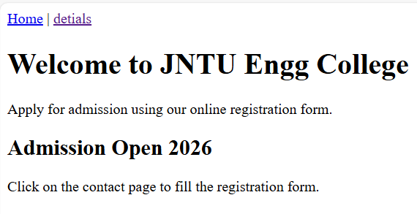
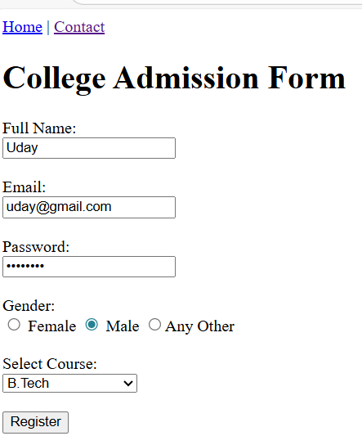

2) Problem Statement : Develop a HTML5 website with a semantic navigation menu and working internal and external links.
HTML CODE :
Index.html :
<!DOCTYPE html>
<html lang="en">
<head>
<meta charset="UTF-8">
<title>Uday Coaching Institute - Home</title>
</head>
<body>

<header>
<h1>Uday Coaching Institute</h1>
</header>

<nav>
<a href="index.html">Home</a> |
<a href="courses.html">Courses</a> |
<a href="contact.html">Contact</a>
</nav>

<main>
<h2>Welcome to Our Institute</h2>
<p>We provide precious knowledge and quality coaching for various Programming Languages.</p>

<h3 id="about">About Us</h3>
<p>Our institute have excellent placements and experienced faculty .</p>

<p>
<a href="#about">Go to About Section</a>
</p>

<p>
Follow us on
<a href="https://www.linkedin.com/in/udaykirankomara" target="_blank">linkedin</a>
</p>
</main>

</body>
</html>
Courses.html :

<!DOCTYPE html>
<html lang="en">
<head>
<meta charset="UTF-8">
<title>ABC Coaching Institute - Courses</title>
</head>
<body>

<header>
<h1>Our Courses</h1>
</header>

<nav>
<a href="index.html">Home</a> |
<a href="courses.html">Courses</a> |
<a href="contact.html">Contact</a>
</nav>

<main>
<h2>Courses We Offer</h2>

<ul>
<li>Java FullStack</li>
<li>.Net FullStack</li>
<li>Communication</li>
<li>Python FullStack</li>
</ul>

<p>
<a href="index.html">Back to Home</a>
</p>
</main>
</body>
</html>
contact.html :
<!DOCTYPE html>
<html lang="en">
<head>
<meta charset="UTF-8">
<title>Uday Coaching Institute - Contact</title>
</head>
<body>

<header>
<h1>Contact Us</h1>
</header>

<nav>
<a href="index.html">Home</a> |
<a href="courses.html">Courses</a> |
<a href="contact.html">Contact</a>
</nav>

<main>
<h2>Get in Touch</h2>

<p>Address: 5th Floor, Tambaram, Chennai</p>
<p>Phone: +91 7569983999</p>
<p>Email: udcoaching@gmail.com</p>

<p>
<a href="courses.html">View Our Courses</a>
</p>
</main>

</body>
</html>
- Technical Explanation : Uses semantic <nav> and relative <a> links to connect multiple HTML pages with internal and external navigation
- OUTPUT:

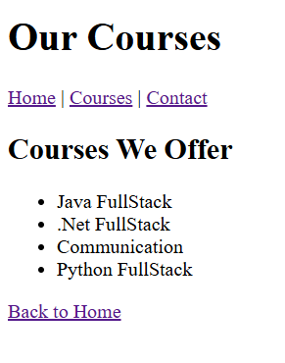

3) Problem Statement : Create a student registration form using HTML5 input types with built-in validation for accurate data entry.

OUTPUT :
<!DOCTYPE html>
<html lang="en">
<head>
<meta charset="UTF-8">
<title>Student Registration Form</title>
</head>
<body>

<h2>Student Registration Form</h2>

<form>
<label for="name">Name:</label>
<input type="text" id="name" name="name" placeholder="Enter your name" required>
<br><br>

<label for="email">Email:</label>
<input type="email" id="email" name="email" placeholder="Enter your email" required>
<br><br>

<label for="phone">Phone:</label>
<input type="tel" id="phone" name="phone"
placeholder="10-digit phone number"
pattern="[0-9]{10}"
required>
<br><br>

<label for="age">Age:</label>
<input type="number" id="age" name="age" min="16" max="60" required>
<br><br>

<label for="dob">Date of Birth:</label>
<input type="date" id="dob" name="dob" required>
<br><br>

<input type="submit" value="Register">

</form>

</body>
</html>
- Technical Explanation :
Implements semantic <form> with labeled HTML5 inputs and attributes like required, min, max, and pattern to enable automatic browser validation without JavaScript.
OUTPUT:
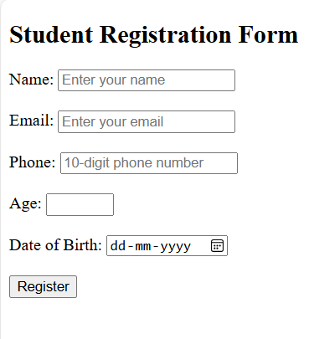
4) Problem Statement : Build a hierarchical multi-page HTML5 website with breadcrumb navigation to show the user’s current location.

- HTML CODE :
Folder Structure :
Day2_HTML_1
│── index.html
│
── courses
│ └── index.html
│
└── web
│── index.html
└── html.html
- HTML CODE :
Index.html :
<!DOCTYPE html>
<html lang="en">
<head>
<meta charset="UTF-8">
<title>Home</title>
</head>
<body>

<nav>
<a href="index.html">Home</a> |
<a href="courses/courses.html">Courses</a>
</nav>

<h1>Welcome to Training Portal</h1>

</body>
</html>
- ── courses
└── index.html
<!DOCTYPE html>
<html lang="en">
<head>
<meta charset="UTF-8">
<title>Home</title>
</head>
<body>

<header>
<h1>Training Portal</h1>
</header>

<nav>
<a href="index.html">Home</a> |
<a href="courses/index.html">Courses</a>
</nav>

<hr>

<h2>Welcome</h2>
<p>This is the home page of the training portal.</p>

</body>
</html>
- └── web
│── index.html
<!DOCTYPE html>
<html lang="en">
<head>
<meta charset="UTF-8">
<title>Web Development</title>
</head>
<body>

<header>
<h1>Web Development</h1>
</header>

<nav>
<a href="../index.html">Home</a> |
<a href="../courses/index.html">Courses</a>
</nav>

<p>
<a href="../index.html">Home</a> >
<a href="../courses/index.html">Courses</a> >
Web Development
</p>

<hr>

<h2>Web Development Course List</h2>

<ul>
<li>
<a href="html.html">HTML Course</a>
</li>
</ul>

</body>
</html>
- └── htm.html
<!DOCTYPE html>
<html lang="en">
<head>
<meta charset="UTF-8">
<title>HTML Course</title>
</head>
<body>

<header>
<h1>HTML Course</h1>
</header>

<nav>
<a href="../index.html">Home</a> |
<a href="../courses/index.html">Courses</a>
</nav>

<p>
<a href="../index.html">Home</a> >
<a href="../courses/index.html">Courses</a> >
<a href="index.html">Web Development</a> >
HTML Course
</p>

<hr>

<h2>About HTML</h2>
<p>HTML is the standard language for creating web pages.</p>

</body>
</html>

- Technical Explanation :

Uses semantic <nav> and relative links to implement folder-based page hierarchy with dynamic breadcrumb trails reflecting the navigation path.
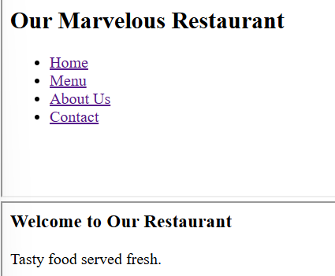
- OUTPUT:
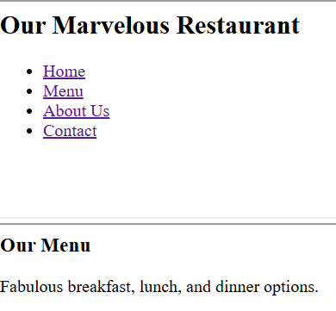
- [Grab your reader’s attention with a great quote from the document or use this space to emphasize a key point. To place this text box anywhere on the page, just drag it.]

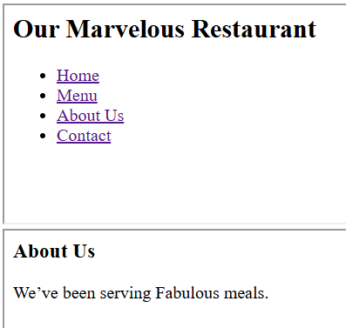
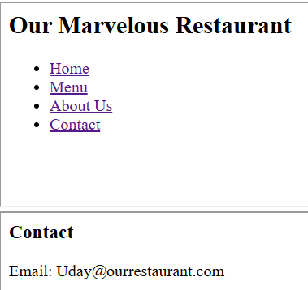

5) Problem Statement : Design an HTML5 course enrollment form using advanced elements like <datalist>, <progress>, and <meter> with built-in validation.
- HTML CODE :
<!DOCTYPE html>
<html lang="en">
<head>
<meta charset="UTF-8">
<title>Course Enrollment Form</title>
</head>
<body>

<header>
<h1>Course Enrollment</h1>
</header>

<main>

<form>

<fieldset>
<legend>Student Information</legend>

<label for="email">Email:</label>
<input type="email" id="email" required>
<br><br>

<label for="age">Age:</label>
<input type="number" id="age" min="16" max="60" required>
<br><br>

</fieldset>

<fieldset>
<legend>Course Selection</legend>

<label for="course">Choose Course:</label>
<input list="courses" id="course" required>

<datalist id="courses">
<option value="HTML">
<option value="CSS">
<option value="JavaScript">
<option value="Python">
<option value="Java">
</datalist>

<br><br>
<label for="level">Skill Level:</label>
<meter value="0.6" min="0" max="1">60%</meter>

<br><br>

<label for="range">Interest Level:</label>
<input type="range" min="1" max="10">

</fieldset>

<fieldset>
<legend>Enrollment Status</legend>

<label>Form Completion:</label>
<progress value="70" max="100"></progress>

</fieldset>

<br>

<input type="submit" value="Enroll">

</form>

</main>

<footer>
<p>Online Learning Platform</p>
</footer>

</body>
</html>

- Technical Explanation :
Implements a semantic HTML5 form with modern input types and native elements to provide suggestions, display completion status, and represent skill level without JavaScript.

OUTPUT :
